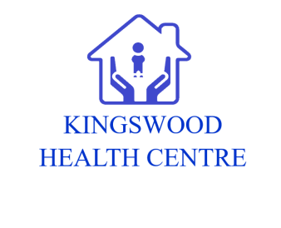
Infection Control Annual Statement
July 2022

1. PURPOSE

In line with the Health and Social Care Act 2008: Code of practice on prevention and control of infection and its related guidance, this Annual Statement will be generated each year in October. It will summarise:

- Details of any infection prevention and control (IC) audits undertaken and any subsequent actions taken arising from these audits
- Details of any issues that may challenge infection prevention and control including risk assessment undertaken and subsequent actions implemented as a result
- Details of staff IC training
- Details of review and update of IC policies, procedures and guidance

2. INFECTION CONTROL LEAD

The Infection Control Leads will enable the integration of Infection Control principles into standards of care within the practice. They will be the first point of contact for practice staff in respect of Infection Control issues. They will help create and maintain an environment which will ensure the safety of the patient / client, carers, visitors and health care workers in relation to Healthcare Associated Infection (HCAI).

The Infection Control Lead will carry out the following within the practice:
- Increase awareness of Infection Control issues amongst staff and clients
- Help motivate colleagues to improve practice
- Improve local implementation of Infection Control policies
- Ensure that practice based Infection Control audits are undertaken
- Assist in the education of colleagues
- Help identify any Infection Control problems within the practice and work to resolve these, where necessary in conjunction with the local Infection Control Team
- Act as role models within the practice
- Disseminate key Infection Control messages to their colleagues within the practice

Practice Infection Control Lead: Sue Maggs / Rachel Simpson

3. SIGNIFICANT EVENTS
COVID 19 has had a massive impact on IFC in the practice. Staff have adapted to new working practices, including PPE.

4. AUDITS / RISK ASSESSMENT
The following audits / assessments were carried out in the practice:
- Infection Control Annual Audit (a paper copy can be obtained from the Infection Control Team)
Date of last risk assessment 16th July 2022

5. AUDIT KEY FINDINGS/RECOMMENDATIONS/UPDATES.
- Sharps bins where temporary lid closures were left open. Sharps bins should be closed and disposed of after 6 months.
- Hand hygiene audit – completed for all clinical and non-clinical staff members during July /Aug 2020.

6. STAFF TRAINING
Infection Control Leads for the Practice have attended Infection Control training in the last year.
New recruits have had infection control training as part of induction as of February 2020 in-house infection control training takes place for every member of staff each year.

7. POLICIES, PROTOCOLS AND GUIDELINES
The Policies below have been updated this year. They are reviewed annually or earlier when appropriate due to changes in regulations and evidence based guidance.
  - Clinical Waste Protocol
  - Contagious Illness Policy
  - COSHH Policy
  - Disposable Single Use Instrument Policy
  - Hand Hygiene Policy
  - Infection Control Biological Substances Incident Protocol
  - Infection Control Inspection Checklist
  - Infection Control Policy
  - Needlestick Injuries Policy
  - Patient Isolation Policy
  - PPE Policy
  - Specimen Protocol
  - Staff Screening & Imms Policy

